A survivor’s guide on how to enjoy sirens without succumbing to their charms!

The purpose of this course is the reading and discussion of advanced material centered exclusively on the topic of Mermaids, Undines, and Nixies in German Culture. Students will have the opportunity to improve their written and oral proficiency in German while reflecting on issues of gender and sexuality, and nature versus culture.

Christophe Koné
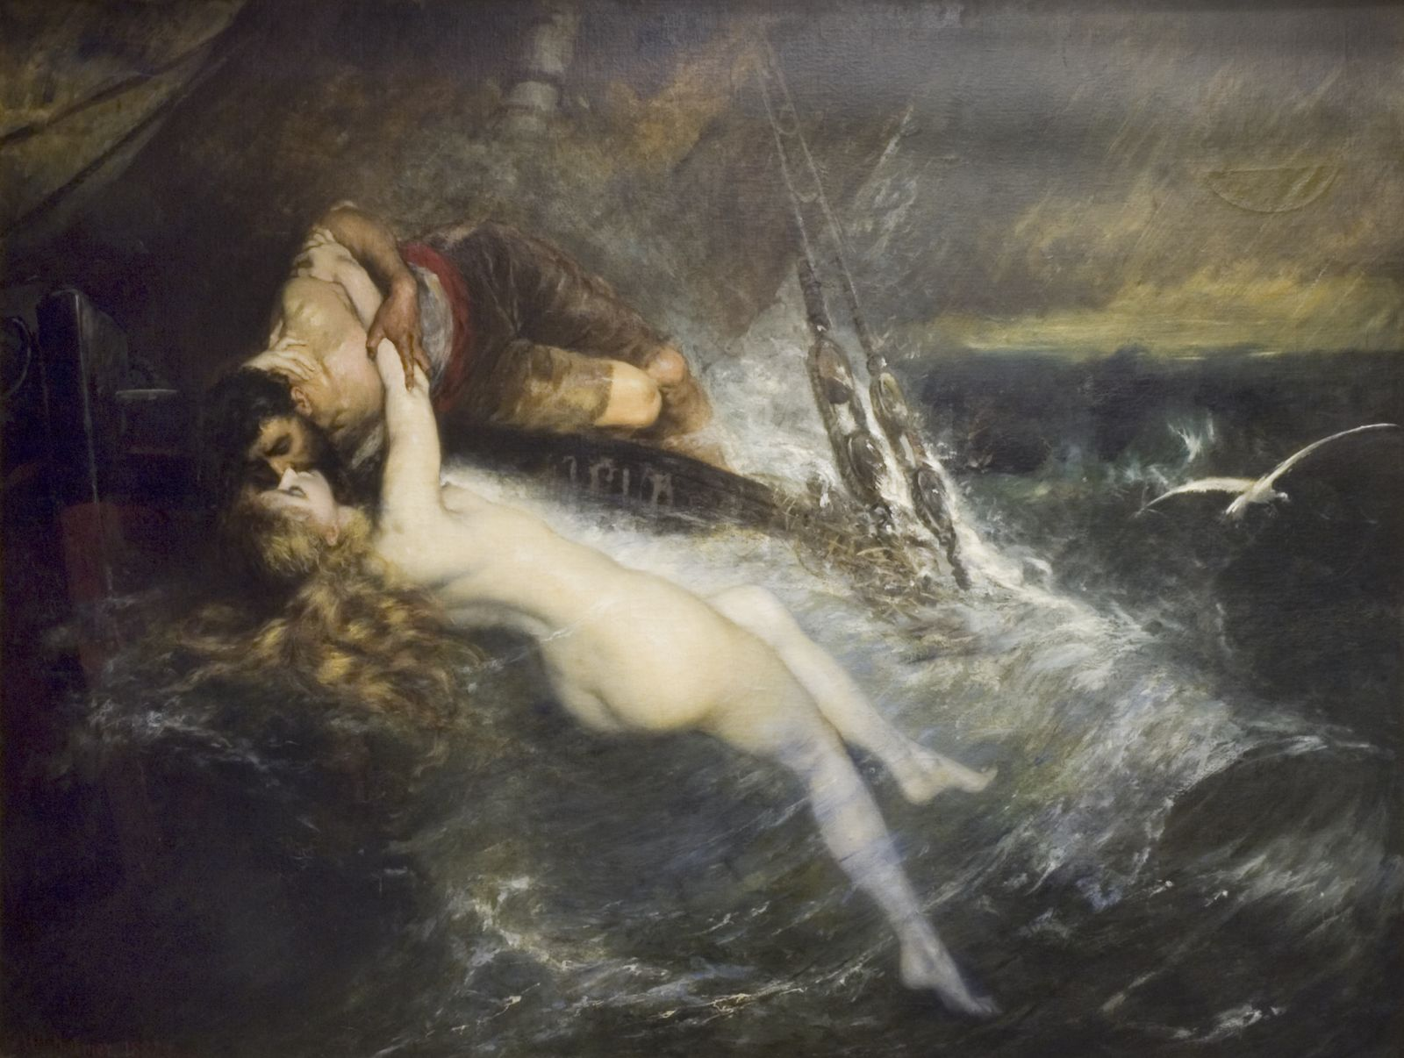
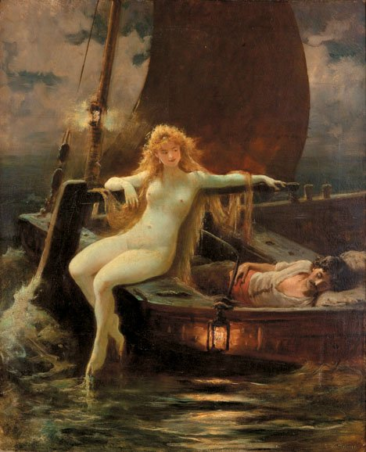
German House
172 College Avenue, New Brunswick, NJ 08901
Main office telephone: 732-932-7201
E-Mail: christko@eden.rutgers.edu

Advanced Conversation and Composition
01:470:232:01; index number: 49200
3 credits
Tuesday & Thursday 2:50 PM – 4:10 PM
Scott Hall Room # 216 (College Avenue Campus)

Activities and assignments will focus on intensive practice of sentence structure and expository writing. We will read a collection of short stories and poems, look at paintings, watch movies and listen to songs that serve as a basis for class discussion. These will also be the starting points for written and oral work.
Taught in German. All readings, discussion, and written work for the course will be in German

PREREQUISITES: 01:470:231 or the equivalent.
Course credits count toward general credits for German major or minor.

Final Grade
Attendance + class participation 10%
2 Oral Presentations 30%
3 Essays 30%
Midterm Exam + Final Exam 30%

Grades will be posted in the online SAS grade book under the following link:
https://secure.fas.rutgers.edu/apps/gradebook/
(Students must pass exam to pass course)

Course grades as follows:
A=90-100%; B+=85-89%; B=80-84%; C+=75=79; C=70-74; D=66-69; F=65 and below

Required Texts

Available at the Rutgers Bookstore, Barnes & Nobles in New Brunswick, and on Amazon.com

Handbuch zur deutschen Grammatik 5th edition (textbook) by Rankin & Wells

ISBN-10 # 143908278
ISBN-13 # 978-1439082782
I would also recommend that you invest in a soft-cover German-English/English-German dictionary.

Attendance
All students must attend regularly and arrive prepared; if you expect to miss one or two classes, please use the University absence reporting website https://sims.rutgers.edu/ssra/ to indicate the date and reason for your absence. An email is automatically sent to me. Those who miss more than two class sessions without a compelling excuse should expect a one-step reduction in the course grade (i.e. an A becomes a B+, a B+ becomes a B). Absences for reasons of religious obligation are excused, however, students are advised to provide timely notification to instructors about necessary absences for religious observances and are responsible for making up the work or exams according to an agreed-upon schedule Every additional three absences may entail a further one-step grade-reduction. Three late arrivals count as one absence. Note: It is the responsibility of students who have been absent (for any reason) to find out what they have missed and obtain materials that may have been handed out..

German Conversation Group
Since this class focuses on advanced conversation, students are strongly encouraged to regularly attend the German Conversation Group offered by the Language Lab (schedule to be announced).

Academic Integrity
Violations of academic integrity are an extremely serious matter, and can lead to a student’s failing the course and being referred to the University’s Office of Student Conduct for disciplinary action. When referring to ideas other than your own, always acknowledge your sources clearly and completely, whether you are quoting or paraphrasing. Note also that use of online translation services is not permitted as a tool for generating work that you submit for course credit. Please see the University’s policies on academic integrity at http://academicintegrity.rutgers.edu/, and discuss with your instructor any questions you may have about this and related issues.

Essay writing & academic Standards
All undergraduate students at Rutgers are required to complete Expository Writing (English 101). The basic principles of academic writing learned in that course are applicable for all subsequent courses at Rutgers, including this one. All written work for this course, while written in German, should fulfill these requirements of close reading and critical argumentation. Please refer to materials from your own Expository Writing course and refer to the Writing Program website at http://wp.rutgers.edu/component/content/article/60-course-listing/55-355101

Photocopies
Department photocopying fees add up quickly and impressively. Therefore, the department charges five cents per page for any handouts given throughout the semester. Not included in this fee are the syllabus, quizzes, and tests. As an alternative, most handouts will be posted on the course Sakai page. Print these handouts yourself and bring to class to avoid departmental photocopying fees.

Class Website
You can find a website for the course under the following link: http://sakai.rutgers.edu. You should be enrolled and have access automatically if you are a registered Rutgers student and have signed up for the class. Just use your NetID and password. If not, then please contact me and I will give you access. Please check the website frequently for the most recent announcements, worksheets and assignments, or to chat with fellow classmates.

Homework
All readings are due on the day that they are to be talked about in class.
We will be covering the first half of Handbuch zur deutschen Grammatik this semester in order to review all the basic points of German grammar and uncover any problem spots. Reading the lessons carefully, preparing any required exercises from the book, and coming prepared with any questions all count toward your class participation. In the interest of time, we cannot go over every single grammar exercise assigned for homework. We will correct a few but you are strongly encouraged to do them all in order to get more practice and master German grammar. Note also that you will take a vocabulary/grammar quiz at the beginning of every class session on the chapter covered during the preceding class.

Class participation
All students are expected to come to class well prepared in order to take part actively in the class discussion. To this end, each student enrolled in this class is expected to give a 10-minute oral presentation in German on one of the materials listed on the syllabus, raising questions or discussing themes that strike him or her as important. The other students must be ready to ask questions and take part in an interesting and productive discussion on love and violence. The idea is to turn this class into a lively and exciting seminar. Other texts and any audio materials will posted on Sakai in a timely manner or distributed in class.

Disability Statement
Students who may be requesting accommodations due to disabilities are encouraged to familiarize themselves with procedures and policies regarding disability support services at the following website: http://disabilityservices.rutgers.edu/. It is recommended that students seeking accommodations begin filing paperwork as soon as possible as the documentation review process may take up to 30 business days. Students are encouraged to speak with teachers about these issues at the beginning of the term. All such conversations will be kept strictly confidential.

Official Roster and In-Class Names
For grading purposes, your legal name must be used on the roster and for all online registrations and activities. However, if you wish to be identified by a different name in class and by your classmates, please let the instructor know.
Additional Information
Cell phones and all other technological devices (beepers, iPods, MP3players...) must be turned off during class out of respect for the instructor and fellow students. Please schedule all important phone communications outside of class time.

Syllabus

Di. 22. Januar Introduction: schedule, course background information, expectations

Do. 24. Januar Musik: Richard Wagner,
“Das Rheingold”
Vorspiel & 1. Szene

Di. 29. Januar Gedicht: Clemens Brentano
“Zu Bacharach am Rheine”

Do. 31. Januar Gedicht: Heinrich Heine,
“Die Lorelei”
Song: Ella Fitzgerald, “Lorelei”

Di. 5. Februar Gedicht: Johann Wolfgang Goethe
“Der Fischer”
Lied: Franz Schubert, “Der Fischer”

Do. 7. Februar Märchen: Hans Christian Andersen,
“Die kleine Seejungfrau” S. 66-82

Di. 12. Februar Märchen: Hans Christian Andersen,
“Die kleine Seejungfrau” S. 82-95

Do. 14. Februar Gedicht: Achim von Arnim
“Ritter Peter von Stauffenberg und die Meerfeie” Romanze I-IV

Di. 19. Februar Gedicht: Achim von Arnim
“Ritter Peter von Stauffenberg und die Meerfeie” Romanze V-VII
Aufsatz #1

Do. 21. Februar MIDTERM EXAM

Di. 26. Februar Erzählung: Friedrich de la Motte- Fouqué, “Undine” Kapitel 1-3

Do. 28. Februar Erzählung: Friedrich de la Motte- Fouqué, “Undine” Kapitel 4-6

Di. 5. März Erzählung: Friedrich de la Motte- Fouqué, “Undine” Kapitel 7-10

Do. 7. März Erzählung: Friedrich de la Motte- Fouqué, “Undine” Kapitel 11-13

Di. 12. März Erzählung: Friedrich de la Motte- Fouqué, “Undine” Kapitel 14-17

Do. 14. März Erzählung: Friedrich de la Motte-
Fouqué, “Undine” Kapitel 18-19

Di. 26. März Film: Neil Jordan, “Ondine”

Do. 28. März Erzählung: Ingeborg Bachmann
“Undine geht” Aufsatz #2

Di. 2. April Erzählung: Barbara Frischmuth
“Otter”
Do. 4. April Erzählung: Johann Wolfgang Goethe
“Die neue Melusine” aus Wilhelm Meisters Wanderjahre Kapitel 1

Di. 9. April Erzählung: Johann Wolfgang Goethe
“Die neue Melusine” aus Wilhelm Meisters Wanderjahre Kapitel 2

Do 11. April Erzählung: Johann Wolfgang Goethe
“Die neue Melusine” aus Wilhelm Meisters Wanderjahre Kapitel 3

Di. 16. April Erzählung: Johann Wolfgang Goethe
“Die neue Melusine” aus Wilhelm Meisters Wanderjahre Kapitel 4

Do. 18. April Erzählung: Eduard Mörike
“Historie der schönen Lau” S. 364-376

Di. 23. April Eduard Mörike
“Historie der schönen Lau” S. 376-390

Do. 25. April Erzählung: Franz Kafka
“Das Schweigen der Sirenen”

Di. 30. April Bild: G ustav Klimt
Die Sirenen / Goldfische
Wasserschlangen I / II

Do. 2. Mai Film: Ron Howard, “Splash”
Roundtable
Aufsatz #3

Fr. 10. Mai FINAL EXAM 12:00 – 3:00 PM

Class Participation Rubric

 | Exceeds expectations  (100-90 %) | Meets expectations  (89-80 %) | Meets some expectations  (79-70 %) | Below expectations  (69-65 %)
Attentiveness and Preparedness | Student is always attentive, prepared, and focused on work assigned. Student does not interrupt the class with anything that does not pertain to class work assigned, i.e. personal conversations, use of electronic devices, etc. | Student is attentive, mostly prepared, and focused most of the time and barely interrupts class work. | Student is sometimes attentive, not always prepared, and interrupts the class at times. | Student is barely attentive, rarely prepared, not focused and/or frequently interrupts the class with anything that does not pertain to class work assigned.
Contribution | Student is always eager to contribute to class, pair and group work and ask questions. Students always volunteers answers. Contributions are beneficial and relevant to class discussion/topic. Student always responds to and engages classmates in a respectful manner. | Student is eager to contribute to class, pair and group work and occasionally asks questions. Student volunteers answers most of the time. Contribution is mostly beneficial to class discussion/topic. Student makes some effort to engage fellow students. | Student occasionally contributes to class, pair and group work and asks questions some of the time. Student volunteers answers some of the time. Contribution is somewhat beneficial to class discussion/topic. Student does not engage classmates beyond the minimum requirements for an assignment. | Student almost never contributes to class, pair and group work, never asks questions or volunteers answers. Contribution is irrelevant to class discussion/topic.
Use of German | Student only speaks German with classmates and instructor during class; shows resourcefulness and imagination when using the language. | Student tries to speak German most of the time during class, but still switches to English; completes exercises with some imagination and resourcefulness. | Student barely speaks German during class and prefers to speak English; responds and completes exercises with minimal imagination. | Student almost never speaks German during class and speaks mostly English.

